Essex Ethanol Modules – Boyd French

Brief History

I joined the Thamesiders group in early 2007 and had no modules at that time but assisted Mike Meadows in erecting his TBR intermodal yard. I was interested in building a module so Mike M suggested an Ethanol Plant that could connect to his modules via a spur and link up with his grain silos. So I started building a module in March 2008.

Essex Ethanol Modules

Essex Ethanol comprises two 4’ x 2’ modules. The first module built contains the storage tanks and mixing tanks and linked to TBR via the mainline and a spur. I also incorporated a passing loop to link to TBR’s passing loop to increase the length of a train that could be accommodated. Later a second board was added to include the processing plant which was sandwiched between my first board and TBR thus increasing the length of the passing loop. This module also included a maintenance shed. A plan of the two boards is shown below.

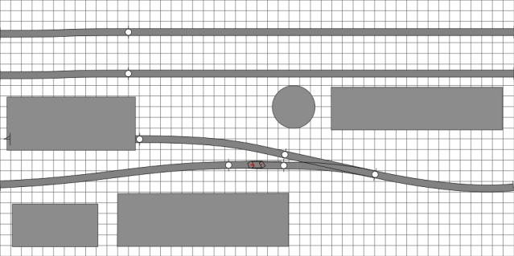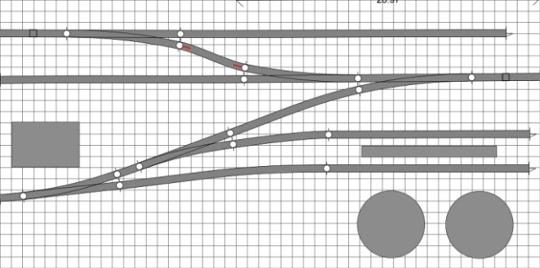

Module 2 Module 1

The first board I inherited from the club as it was spare, however the surface was not very flat so a lot of levelling of the track was required. A few photos below show the early stages of track laying and wiring.

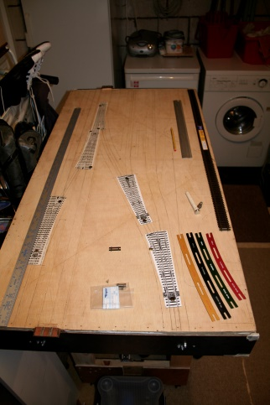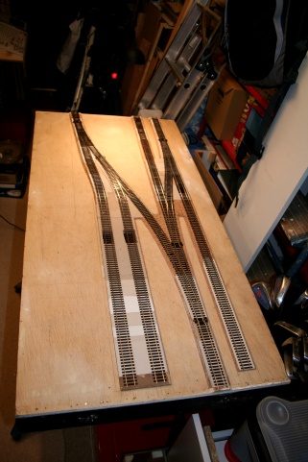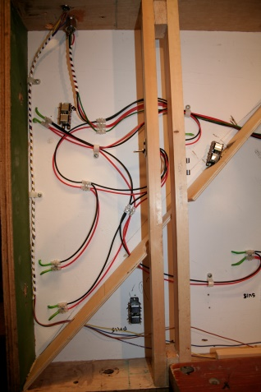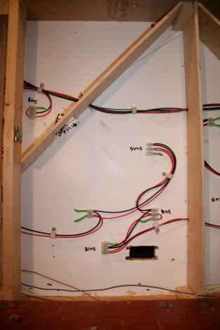

The end templates fitted to the ends of the modules would ensure correct track alignment of the main line and provision was made for 3 electromagnetic couplers, hence the rectangular holes shown in the photo below left.

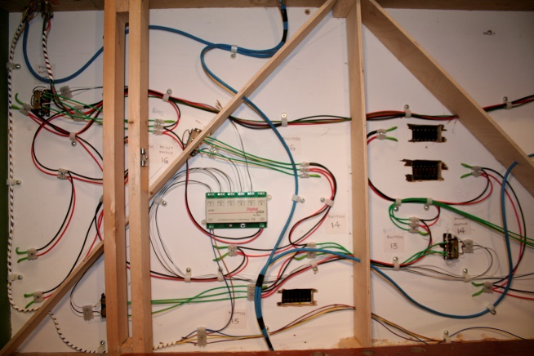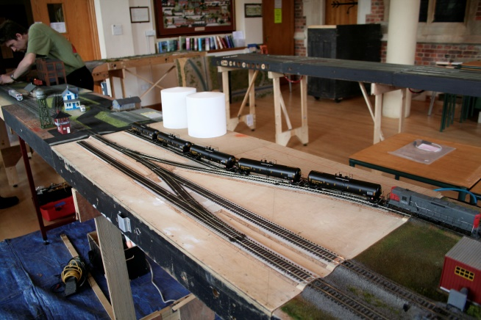

The photo above left also shows the wiring of the Lenz LS150 for point operation, which at that time were Peco motors. The right hand photo shows the module connected up to the layout. The scenic planning has started showing the placement of the two storage tanks. This was at our old venue, Hatfield Peveral Church hall.

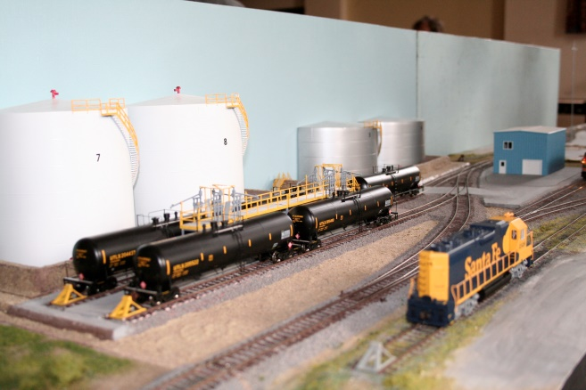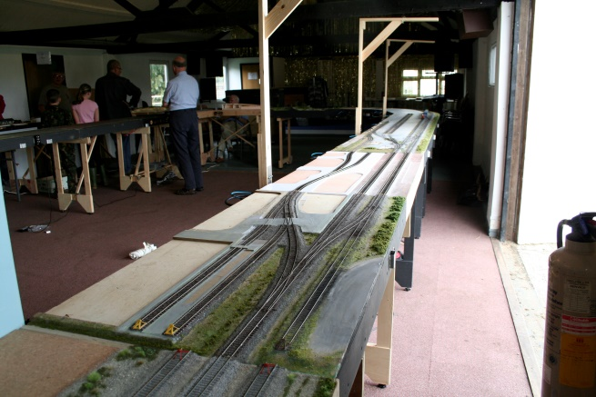

Further scenery was added as shown in the photo on the left. The photo on the right shows both modules and by then we had moved to our new premises at Whitegate’s Farm. Further scenery was added as shown below.

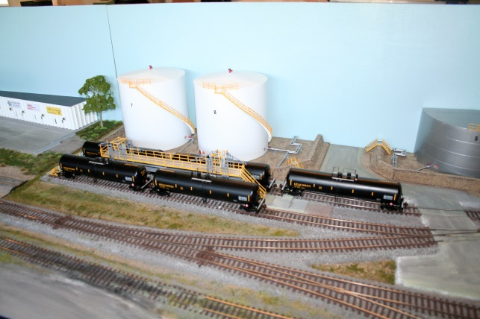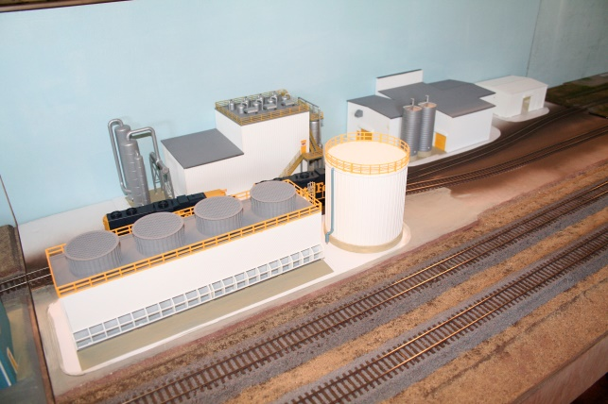

The photos below show the detail of the modules at the Warley MRE in November 2010.

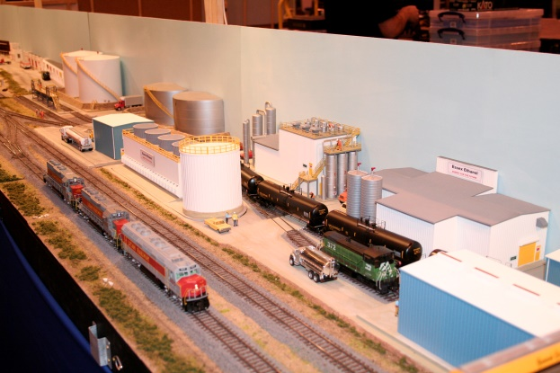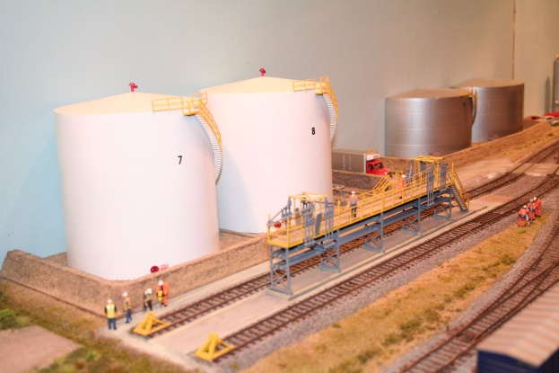

. The current stage of the modules is shown below. The photos were taken at Alexandra Palace in March 2013.

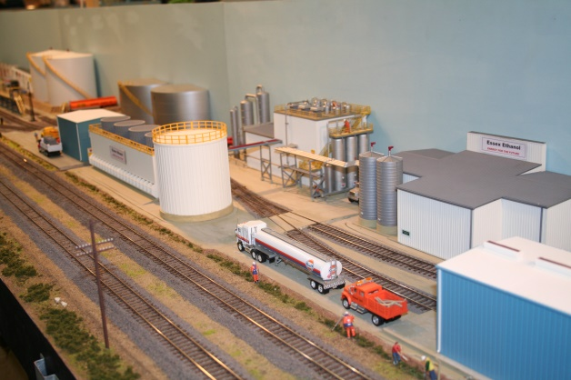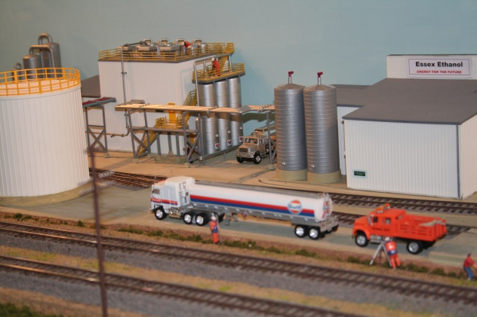

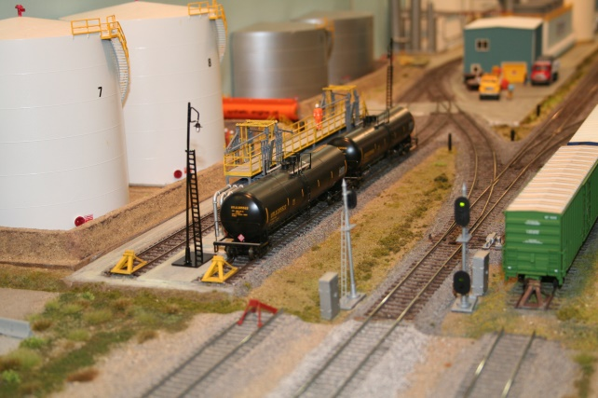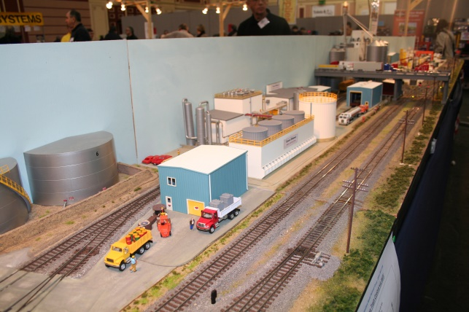

Operating signals are now included but these will be replaced with a new centrally controlled signalling system. The plant is still not finished as further detailing is planned including yard lights and some light weathering. Some of the Peco points have been replaced with Cobalt point motors.

Boyd French
February 2015

